Energy crisis in Europe revamps the economic competitiveness of green chemicals
Abhinandan Nabera, Ioan-Robert Istrate, Javier Pérez-Ramírez and Gonzalo Guillén-Gosálbez*
Institute for Chemical and Bioengineering, Department of Chemistry and Applied Biosciences, ETH Zürich, Vladimir-Prelog-Weg 1, Zürich 8093, Switzerland
*Corresponding author: gonzalo.guillen.gosalbez@chem.ethz.ch

Context and scale

Ammonia and methanol are the most important chemicals in our daily lives. Both these chemicals majorly use natural gas as a feedstock for their production, resulting in higher CO₂ emissions. Various research has been carried out in abundance to produce these chemicals in a more environmentally sustainable manner. However, the economics of such alternative production routes was found to be infeasible. Nonetheless, the current scenario in Europe paints a different picture when natural gas prices become volatile. In this work, a cost-benefit analysis of the changing production costs for fossil ammonia and methanol is compared with the greener production routes resulting from the current state of affairs in Europe. In addition to emitting less CO₂, the alternative production routes were cost-competitive and, in some cases, even cheaper than their fossil counterparts.

Summary

Green hydrogen produced via water electrolysis using renewable electricity sources is a possible alternative to lower greenhouse gas (GHG) emissions related to ammonia and methanol production. However, the economics of green hydrogen acts as a bottleneck making this route impracticable. Here, we show that these alternative production routes have become economically feasible in the current scenario where natural gas prices are skyrocketing due to the geopolitical outline. Green ammonia produced from hydrogen via water electrolysis using on-shore wind electricity was found to be economically competitive or similar (<5%) to the fossil route for six months since December 2021. The lowest feasible monthly average production cost for wind-based ammonia was around 1,290 USD t⁻¹ in December 2021 in comparison to 1,396 USD t⁻¹ for the fossil route. Similarly, wind-based methanol was found to be economically feasible compared to fossil methanol for one month during the peak of natural gas prices in Europe. This study makes us realize the importance and need of the hour to invest in alternative routes for the production of chemicals, starting with ammonia and methanol.

Introduction
The chemical industry is the industrial sector with the highest energy demand as it uses fossil fuels as feedstock and fuel. About 14% and 8% of global oil and gas, respectively, are consumed by the chemical industry¹, which is also responsible for 5.6 Gt CO₂-eq yr⁻¹ (including direct and indirect emissions), equivalent to roughly 10% of global anthropogenic greenhouse gas (GHG) emissions^{2,3}. Out of all the chemicals, ammonia, methanol, ethylene, and propylene are the primary building blocks of the chemical industry, which are further used as raw materials for the production of valuable products. Notably, ammonia is critical to producing mineral nitrogen fertilizers and ensuring global food security^{4,5}. At the same time, methanol is used mainly for producing valuable products (e.g., formic acid, acetic acid, dimethyl ether, and methylamine) and can serve as an intermediate to olefins and aromatics^{1,6}. Ammonia is predominantly produced from hydrogen and nitrogen via the Haber-Bosch process. About 70% of global ammonia production uses natural gas as feedstock, responsible for about 20% of the industrial natural gas demand and ca. 520 Mt CO₂-eq yr⁻¹ over the life cycle⁷. Similarly, 65% of global methanol relies on natural gas to produce syngas, which is then converted to methanol via the water-gas shift reaction⁸. The life cycle GHG emissions from global methanol production are around 300 Mt CO₂-eq yr⁻¹.⁸
Current GHG emissions levels of ammonia and methanol production are primarily incompatible with climate goals and the planetary boundary for climate change^{9,10}. Ammonia and methanol are what is known as hard-to-abate commodity primarily due to their strong dependence on natural gas as feedstock. Thus, shifting to renewable feedstocks becomes paramount to mitigate their climate impacts^{11,12}. Low-carbon ammonia production is possible by switching the hydrogen source from natural gas to water electrolysis powered by renewable energy sources like wind or solar^{7,13}. Moreover, carbon capture and utilization (CCU) offers a route to de-fossilize methanol production via CO₂ hydrogenation⁸. Prior works have demonstrated the technical feasibility^{7,13–15} and potential climate benefits^{9,16–18} of the green chemical industry, but the high costs remain a significant barrier¹⁹. Literature estimates suggest that green ammonia and methanol cost twice as much as the natural gas-based counterpart^{9,10}.
The economic competitiveness of green chemicals has mainly been hampered by the high costs of renewable feedstocks (i.e., renewable hydrogen and captured CO₂) compared with natural gas^{9,10}. However, natural gas has seen a sharp increase in prices over the last two years, primarily due to the COVID-19 pandemic, skyrocketing inflation, and the global energy crisis caused by the Russian invasion of Ukraine. Energy supply disruption as a result of the new geopolitical scenario has severely affected Europe, where monthly average natural gas spot prices (i.e., prices for new contracts at the Title Transfer Facility (TTF) trading point) have increased from 560 USD t⁻¹ in July 2021 to 2,300 USD t⁻¹ as of July 2022, while the price of grid electricity has almost quadrupled²⁰. The drastic increase in natural gas and electricity prices has severe consequences for the European chemical industry²¹. Recent news suggests that more than half of Europe’s ammonia production capacity (estimated at around 19 Mt yr⁻¹)¹³ has been shut down due to gas prices^{22,23}.
The energy crisis in Europe could, in principle, improve the economic competitiveness of green ammonia and methanol while laying the foundation for a renewable transition in the European chemical industry. However, while the potential climate benefits have been proven, whether green chemicals can reduce costs in the present state of affairs has yet to be explored. We fill this critical research gap by estimating the production costs for fossil and green ammonia and methanol in Europe, considering the fluctuation in natural gas and electricity prices due to the global energy crisis. For ammonia production, we investigate the Haber-Bosch process considering four typical hydrogen sources¹³: i) grey hydrogen from steam methane reforming (SMR) using natural gas, ii) green hydrogen from water electrolysis using on-shore wind electricity, iii) green hydrogen from water electrolysis using solar photovoltaic (PV) electricity, and iv) blue hydrogen from SMR coupled with carbon capture and storage (CCS). Similarly, we compare four alternative production routes for methanol: i) conventional synthesis from natural gas, ii) synthesis from captured CO₂ and wind-based electrolytic hydrogen, iii) synthesis from captured CO₂ and solar PV-based electrolytic hydrogen, and iv) synthesis from captured CO₂ and blue hydrogen –SMR coupled with CCS–. In all cases, we consider that CO₂ is extracted from the atmosphere by direct air capture (DAC) as this option shows a high potential to reduce GHG emissions with reduced risk of burdens shifting¹⁶. Further details of production routes are presented in the experimental procedures.

Results

Production costs for fossil ammonia and methanol
Considering the natural gas spot prices in Europe, we estimate that the production cost for fossil ammonia has increased from an average of 376 USD t⁻¹ in the period 2019-2020 to 1,344 USD t⁻¹ as of November 2022 (Fig. 1a). Similarly, the cost of production for fossil methanol reached 1,181 USD t⁻¹ in November 2022, compared with 212 USD t⁻¹ in the period 2019-2020 (Fig. 1b). Natural gas spot prices and chemicals production costs have increased steadily since 2020 due to the rising inflation as a consequence of the COVID-19 pandemic. Since February 2022, after the Russian invasion of Ukraine, natural gas prices have fluctuated considerably, and so have the production costs. For example, ammonia production cost ranges from 1,101 USD t⁻¹ in February 2022 to 2,427 USD t⁻¹ in August 2022 (peak of natural gas spot prices). Overall, compared to July 2021, the estimated production cost for fossil ammonia and methanol rose by 102% and 146%, respectively, in November 2022.
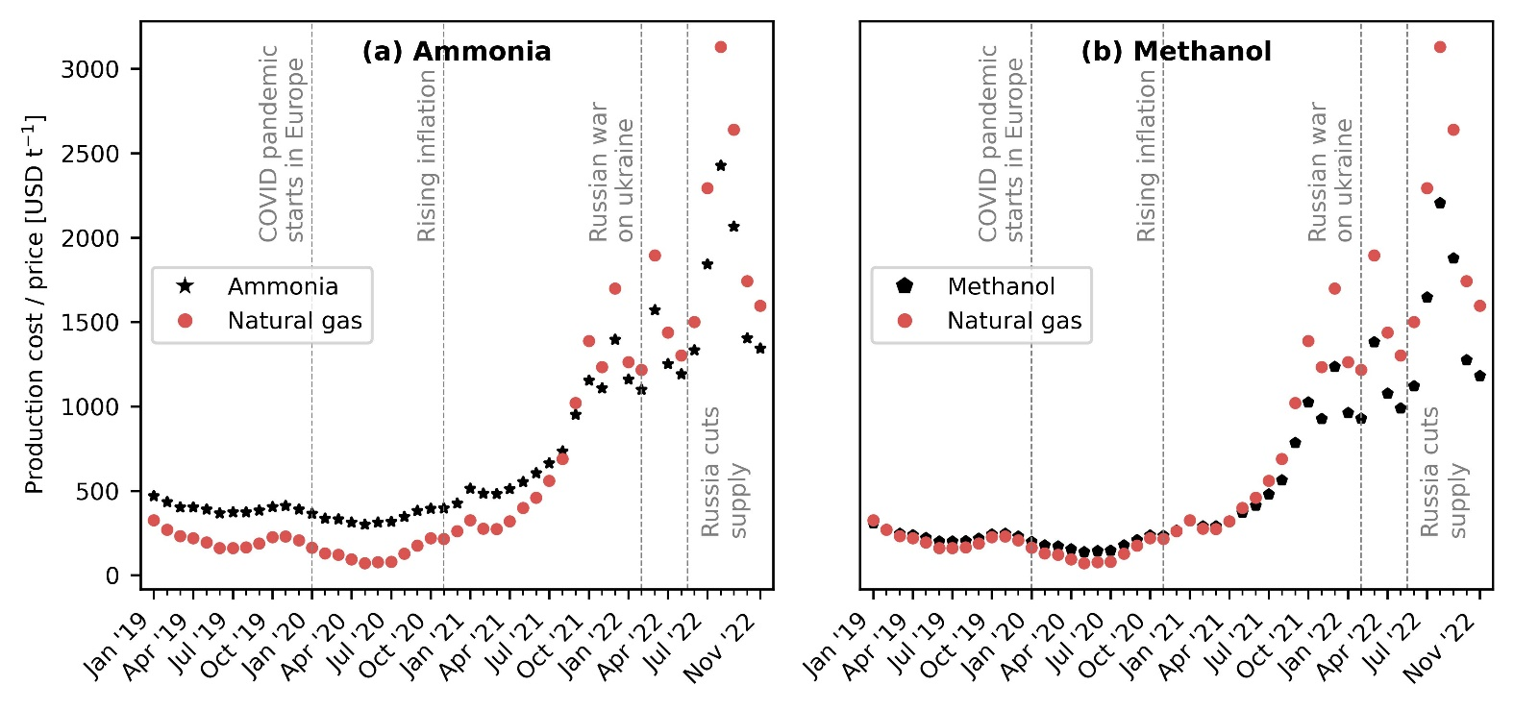
Fig. 1 Evolution of natural gas spot prices and production costs for fossil ammonia and methanol in Europe. (a) Fossil ammonia production via the Haber-Bosch process with grey hydrogen from steam methane reforming (SMR) using natural gas. (b) Fossil methanol synthesis from natural gas. The estimated production costs consider the fluctuation in natural gas and electricity prices due to the global energy crisis.

Economic competitiveness of green ammonia and methanol production routes
We next study the economic competitiveness of green production routes for ammonia and methanol. Green ammonia produced with hydrogen from water electrolysis using wind electricity turns cost-competitive at natural gas prices of around 1,700 USD t⁻¹. Hence, we find that ammonia production via wind electrolysis has been cheaper than or similar to fossil ammonia for six months since December 2021 (Fig. 2a). Within this period, the production costs ranged from 1,290 to 1,590 USD t⁻¹ ammonia. Whereas green ammonia produced via solar PV-based electrolytic hydrogen is only competitive around the peak of natural gas spot prices in August 2022 (Fig. 2b). This can be attributed to lower capacity factors of solar PV (16.1 to 17.5%) in comparison to wind electricity (35.6% to 39%) resulting in higher levelized costs of hydrogen²⁴. Ammonia production with blue hydrogen –SMR coupled with CCS– is always more expensive than the conventional route due to the additional cost of CCS and extra nitrogen feed (Fig. 2c).
Green methanol produced with DAC CO₂ and wind-based electrolytic hydrogen is economically competitive at natural gas prices of around 3,100 USD t⁻¹ (Fig. 2d). However, the break-even natural gas price largely depends on the levelized cost of hydrogen. It could decrease to 2,640 USD t⁻¹ if considering the lower end of the hydrogen cost range. Thus, methanol production via DAC CO₂ and wind electrolysis has been cheaper than or similar to fossil methanol for one and two months since December 2021 if considering the average and lower end of hydrogen cost, respectively. The solar-based route is never feasible even at the peak of natural gas prices (Fig. 2e). For the case of methanol production from DAC CO₂ and blue hydrogen, the cost of production is, on average, 182% higher than fossil methanol due to the additional cost of CCS and captured CO₂ (Fig. 2f).
To investigate further, Fig. 3 shows the breakdown of production costs for fossil and wind-based chemicals production at different time points. We take average values for the years 2019 and 2020 as the natural gas and electricity prices before July 2021 were approximately constant. Notably, the contribution of natural gas to the average production cost for fossil ammonia increased from 21% in 2020 to 44% in July 2021 and up to 63% in November 2022 (Fig. 3a). Similarly, the contribution of electricity increased from 8% in 2020 to 12% in November 2022. For green ammonia, wind-based electrolytic hydrogen has the highest share of the production cost (69% to 85%). Moreover, since wind electricity is used only for the electrolyzer, whereas for the compressors, we consider grid electricity, the share of grid electricity rose from ∼1% in 2020 to 6% in November 2022.
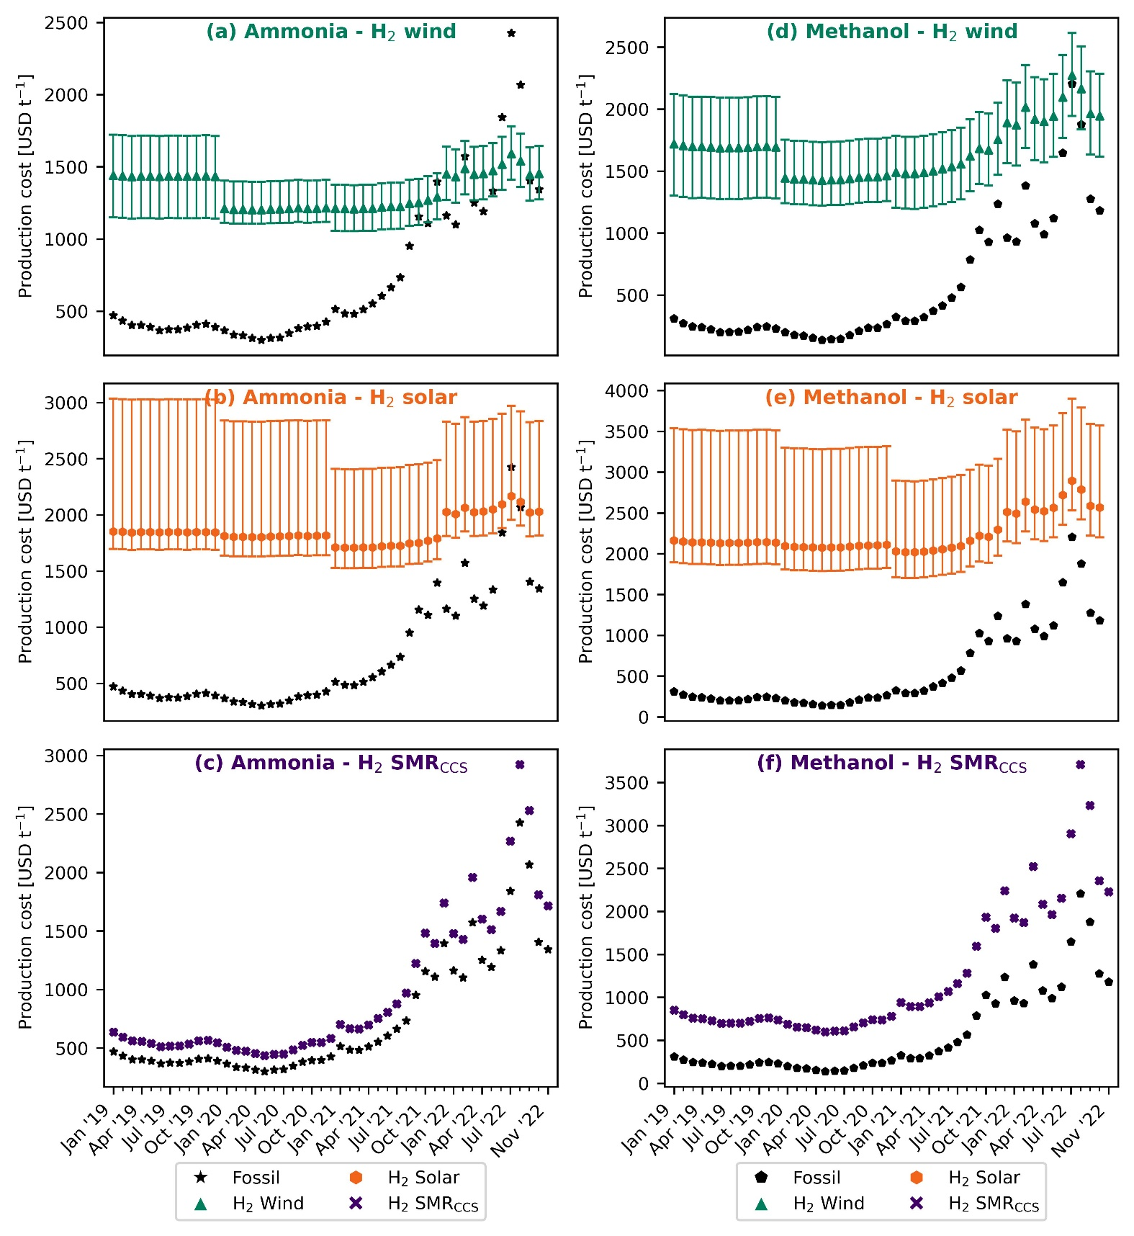
Fig. 2 Evolution of the production costs for green ammonia and methanol in Europe compared with the fossil (natural gas-based) counterpart. Green ammonia production based on the Haber-Bosch process with green hydrogen from water electrolysis using on-shore wind electricity (a) or solar photovoltaic (PV) electricity (b) and blue hydrogen from steam methane reforming (SMR) coupled with carbon capture and storage (CCS) (c). Methanol synthesis from captured CO₂ and wind-based electrolytic hydrogen (d), PV-based electrolytic hydrogen (e) or blue hydrogen –SMR coupled with CCS– (f). The estimated production costs are considering the fluctuation in natural gas and electricity prices due to the global energy crisis. Error bars display the production cost considering the lower and upper bound for the levelized cost of hydrogen.
Similarly, for the production of fossil methanol, the share of natural gas increased from 48% in 2020 to 76% in July 2021 and 88% in November 2022 (Fig. 3b). The contribution of electricity stood at around ∼1% during the entire period considered in our analysis. For the green methanol production route, hydrogen from wind electrolysis had the highest share of around 67% in July 2021, which decreased to 61% in November 2022. The share of CO₂ from DAC was about 16% in 2020 and increased to 28% in November 2022. This increase can be attributed to the increase in natural gas prices required to capture CO₂ via DAC.
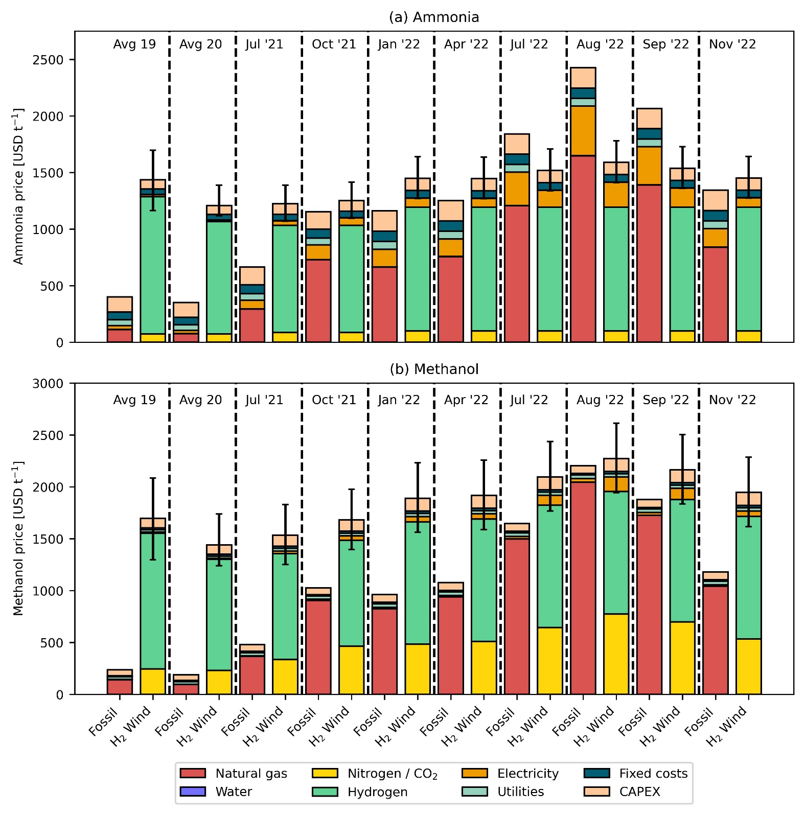
Fig. 3 Breakdown of production costs for fossil and green ammonia (a) and methanol (b). Green ammonia production route based on hydrogen from water electrolysis using on-shore wind electricity. Green methanol production route based on wind-based electrolytic hydrogen and captured CO₂ from direct air capture (DAC). Error bars display the production cost considering the lower and upper bound for the levelized cost of hydrogen.

Avoidance costs
After realizing that green chemical production routes could be economically appealing, we next analyse the avoidance cost, which provides the economic viability of climate change mitigation. The avoidance cost follows an inverse trend to the natural gas price. In 2020 at an average natural gas price of 145 USD t⁻¹, wind- and solar-based ammonia resulted in an avoidance cost of 572 and 1,388 USD t⁻¹ CO₂-eq, respectively (Fig. 4a). This cost is substantially higher for methanol with 1,435 and 7,696 USD t⁻¹ CO₂-eq, respectively (Fig. 4b), primarily due to a higher difference between the production costs of fossil and green methanol. Notably, the avoidance cost of green ammonia and methanol in 2020 essentially surpasses the removal cost of bioenergy with carbon capture and storage (BECCS) and DAC with carbon capture and storage (DACCS), forecasted at 100-200 USD t⁻¹ CO₂ and 100-300 USD t⁻¹ CO₂, respectively²⁵. However, as natural gas prices increase, less money is required for every ton of CO₂ emission avoided by switching from fossil to green chemicals. At the peak of natural gas prices in 2022, the avoidance cost of green ammonia and methanol becomes negative, meaning that the industry could simultaneously reduce costs and GHG emissions. Since July 2021, the industry could save around 56 to 558 USD t⁻¹ CO₂-eq avoided via the wind-based route for ammonia production. Similarly, in August 2022, for methanol via wind, savings stood at around 298 USD t⁻¹ CO₂-eq avoided if considering the lower end of the hydrogen cost range.
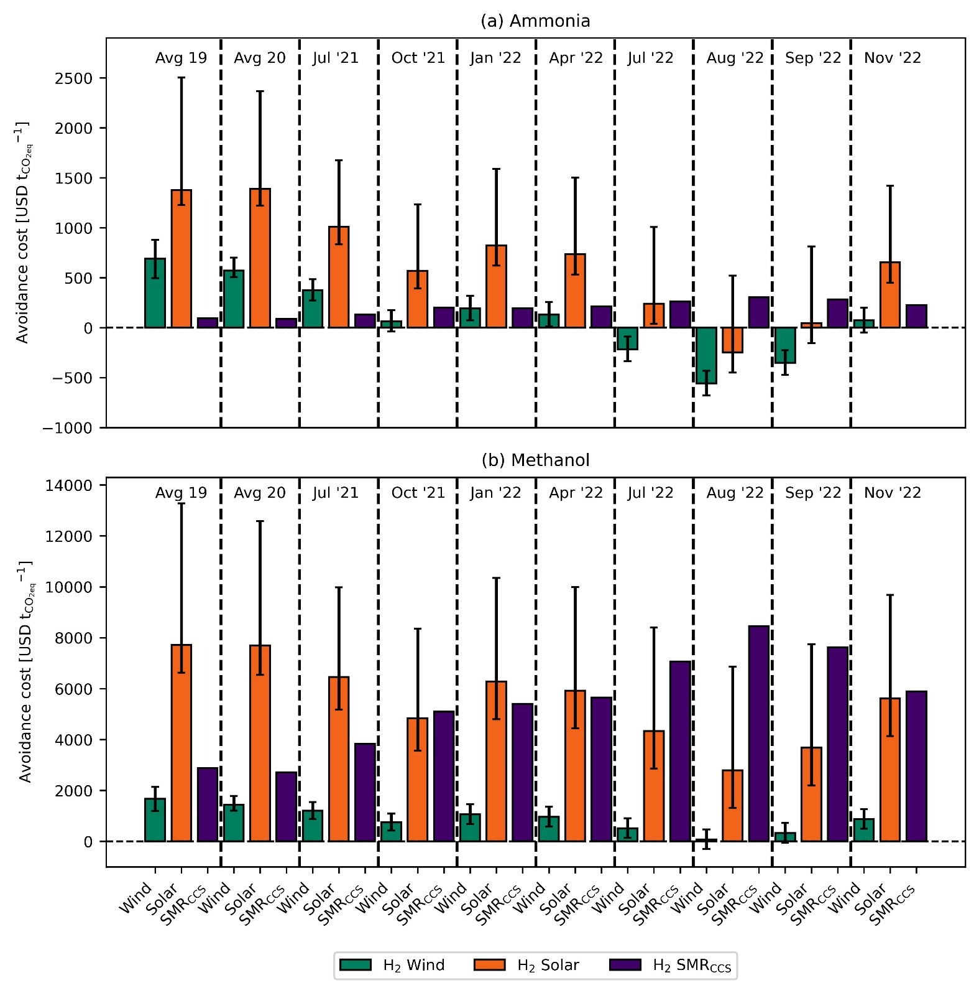
Fig. 4 CO₂-eq avoidance costs for green ammonia (a) and methanol (b). Error bars display the production cost considering the lower and upper bound for the levelized cost of hydrogen.

Discussion
Here we have shown how an unprecedented crisis of soaring natural gas and electricity prices in Europe has improved the economic competitiveness of green chemicals production. Notably, we found that ammonia production via hydrogen from water electrolysis using on-shore wind electricity has generally outperformed natural gas-based ammonia since December 2021. Whether green ammonia will remain economically competitive will depend mainly on the evolution of natural gas prices, which in turn depend on the duration of the war in Ukraine and the adopted measures to diversify gas suppliers (e.g., increased imports of more expensive liquified natural gas). Between December 2022 and January 2023, favourable weather and lower demand from the industry have helped reduce the natural gas prices back to levels before the Russian invasion of Ukraine²⁶. In 2023, considering zero supply from Russia, unpredictable weather conditions, and increasing competition for liquified natural gas, securing natural gas supplies could be a conundrum²⁷. Hence, the World Bank forecasts that natural gas prices will moderate in 2023 but remain well above the average prices registered before 2020²⁰. Other source²⁸ predicts that Europe's natural gas spot price will remain in the range of 1,579 - 2,216 USD t⁻¹. At the same time, the costs of renewable energy technologies –including wind power and electrolyzers– are expected to decline due to the experience effect²⁹. For these reasons, we argue that ammonia production from wind-based electrolytic hydrogen is expected to be cost-competitive in the foreseeable future.
The production costs of chemicals have been historically higher in Europe than in other regions like U.S., Russia, or Saudi Arabia, primarily due to higher labour and feedstock costs³⁰. The disruption of the global energy market in 2022 has further exacerbated this gap since other regions have faced less fluctuation in energy prices due to lower dependence on imports²⁰. For example, between 2020 and 2022, the natural gas price increased by a factor of 1.6 in the U.S. compared with 9.6 in Europe²⁰. Within this context, the chemical industry will shift production to regions with low-cost labour and feedstocks instead of establishing green production routes. However, such relocation would come at the expense of tremendous socio-economic consequences for Europe. In 2020, Europe was the second largest chemicals producer in the world³¹. Given the pivotal role of chemicals across many supply chains, shifting production would mean losing a strategic position while exposing Europe to the vulnerability of supply disruption. This aspect is crucial for ammonia because it is paramount in ensuring food security⁵. Moreover, chemical companies generate about 1.2 million jobs across Europe³¹, which could be lost with production relocation.
In accordance with the Paris Climate Accords, Europe has set targets to reduce emissions by 55% by 2030 and become a net-zero GHG emitting continent by 2050 [European Commision]. In order to achieve these ambitious targets, Europe needs to invest majorly in low-carbon infrastructure. A recent study found that the current pace of investment and development of these technologies is incompetent concerning the targets [Klaaßen et al.]. An additional investment of approximately 94 billion USD yr⁻¹ is required in the immediate future until 2025 in order to achieve the net-zero target by 2050. It was also found that a tremendous investment increase of 26 billion USD yr⁻¹ was needed for renewable power plants, especially solar (7.6 billion USD yr⁻¹) and on-shore wind (17.3 billion USD yr⁻¹) [Klaaßen et al.]. Therefore, negative mitigation costs associated with the production of green ammonia and methanol (especially on-shore wind-based ammonia) appear to the most lucrative options to lower the environmental impact of these essential chemicals. In addition to ensuring supply security, green ammonia and methanol could help the European chemical industry to reduce GHG emissions at a negative mitigation cost, i.e., the industry could save money per unit of CO₂-eq avoided.
Overall, our findings suggest that rising energy prices in Europe can make green ammonia and methanol production routes cost-competitive, thereby overcoming the primary barrier to their implementation (i.e., the high costs compared with fossil routes). The current scenario represents a unique opportunity for the European chemical industry to shift to renewable feedstocks to reduce costs and GHG emissions simultaneously. Such a transition would also have significant benefits for European economies by scurrying the supply of essential commodities that are imperative to ensure food security (i.e., ammonia) and to support the energy transition (i.e., methanol). Moreover, by locally producing renewable feedstocks (i.e., hydrogen and captured CO₂), Europe would further reduce its dependence on imports and its vulnerability to market shocks. However, the debate remains open concerning the potential future dependence of Europe on critical raw materials imports to materialize a complete transition towards renewable energy technologies³².

Experimental procedures
Ammonia production routes. This part of the work was adapted from D’Angelo et al.⁹. For the production of fossil ammonia, natural gas and water are mixed and heated to 858 °C. This stream is then fed to a steam-methane reforming unit (SMR). The SMR reactor converts natural gas to carbon monoxide and hydrogen (syngas). The output from the SMR is then fed into an autothermal reformer (ATR) along with air (78% nitrogen, 21% oxygen, and 1% argon). The oxygen in the air reacts with the residual methane and increases the temperature to 1200 °C inside the ATR. The output from the ATR is cooled to 400 °C and sent to a series of water-gas-shift (WGS) reactors to convert carbon monoxide to carbon dioxide. The two WGS reactors can be differentiated by their operating temperatures. The first one operates at a high temperature (261 °C) and is called the high-temperature water-gas-shift (HTWGS) reactor. The output stream from the HTWGS is fed to a low-temperature water-gas-shift (LTWGS) reactor, which operates at 50 °C. The output stream from the WGS reactors is rich in carbon dioxide, which needs to be removed. To achieve this, it is sent to an absorption column along a lean solvent stream with a composition of 90% water and 10% MEA where 99.7% of the input carbon dioxide is absorbed and removed in the liquid stream. The residual carbon monoxide and carbon dioxide need to be eliminated, so they do not poison the catalyst in the Haber-Bosch process [Ullmann’s Encyclopedia]. Therefore, a methanation unit converts the residual carbon oxides to methane. In the Haber-Bosch process, the carbon dioxide and carbon monoxide free stream is then compressed to 196 bar, mixed with the recycle stream, and sent to a flash separator. This stream is then sent to a series of three reactors where nitrogen and hydrogen react to produce ammonia. As mentioned previously, the outlet stream from these three reactors is cooled and mixed with the fresh feed and sent to a flash unit. The liquid stream from this flash is rich in ammonia which is further purified with a pair of flash separators to meet industrial standards (99.6%). For the production of ammonia using green hydrogen (on-shore wind- or solar-based) and blue hydrogen (-SMR coupled with CCS-), nitrogen from cryogenic air separation and hydrogen is mixed in the ratio 1:3 and sent to the Haber-Bosch process described earlier. A Proton Exchange Membrane (PEM) electrolyzer with a stack lifetime of 60000 hours is considered for producing green hydrogen via water electrolysis using on-shore wind or solar electricity. The assumptions and calculations for the LCOH are explained in detail in the supplemental experimental procedures (see section 1.3).

Methanol production routes. This part of the work was adapted from González-Garay et al.¹⁰. Similar to fossil ammonia, the production of fossil methanol begins with the production of syngas from natural gas via SMR. The syngas is then compressed to 110 bar, mixed with the recycle streams and then heated to 150 °C. This stream is fed to a plug-flow reactor where syngas is converted to methanol according to the kinetics extracted from the work done by Vanden Bussche et al.. The output stream from the reactor is cooled to 38 °C and sent to a flash separator. A small portion of the gas stream from the flash separator is purged whereas the rest is pressurized to 110 bar and recycled. The liquid stream from the flash separator is expanded to 2 bar and sent to a second flash unit, where the gas stream is again pressurized to 110 bar and recycled, and the liquid stream is sent to a distillation column. The distillation column separates liquid methanol (at the condenser) with a purity of 99.9% and water (at the bottom). To produce methanol using green and blue hydrogen, carbon dioxide from direct air capture (DAC) and hydrogen is mixed with the recycle streams, compressed to 50 bar, and heated to 180-280 °C. This stream is then sent to a reactor where, the reverse water-gas-shift (RWGS) reaction takes place, converting carbon dioxide to carbon monoxide, which is consequently hydrogenated to methanol. Similar to fossil methanol, the outlet from the reactor is sent to a series of two flash separators where the gas stream from the first flash is recycled (with a purge). The liquid stream from the second flash unit is sent to a distillation column which recovers methanol at a purity of 99.9%. The carbon dioxide fed to the reactor is obtained via the DAC technology adapted from the work done by Keith et al.. In the work done by Keith et al., aqueous potassium hydroxide (KOH) is used as a sorbent and a caustic calcium cycle is implemented for the regeneration of KOH. However, energy from natural gas is required for the calciner in the recovery cycle. Around 0.11 tons of natural gas is required per ton of carbon dioxide captured [Keith et al.]. For the green routes, the LCOH calculations are described in detail in the supplemental experimental procedures (see section 1.3).

Economic assessment. The detailed procedure adapted for the economic assessment of ammonia and methanol using fossil resources or green hydrogen is described in the supplemental experimental procedures (see section S1).
Avoidance costs. The CO₂-eq avoidance costs in USD t⁻¹_{CO2-eq} are calculated as follows:
$${\text{CO}}_{\text{2-eq }}\text{ avoidance costs [}\frac{\text{USD}}{{\text{t}}_{{\text{CO}}_{\text{2-eq}}}^{\text{-1}}}\text{] = }\frac{{\text{PC}}_{\text{ALT}}\text{ - }{\text{PC}}_{\text{BAU}}}{{\text{GWP}}_{\text{BAU}}\text{ - }{\text{GWP}}_{\text{ALT}}}\text{ (Equation 1)}$$
PC_{BAU/ALT} represents the production cost in USD t⁻¹ for the fossil (BAU) and alternative (ALT) routes. Similarly, GWP_{BAU/ALT} represents the global warming potential in t_{CO2-eq} t⁻¹ for the fossil (BAU) and alternative (ALT) production routes. The methodology implemented to calculate the GWP values are described in the supplemental experimental procedures (see section S2).

References
1. IEA (2018). The Future of Petrochemicals: Towards more sustainable plastics and fertilisers (International Energy Agency).
2. Bauer, F., Tilsted, J.P., Pfister, S., Oberschelp, C., and Kulionis, V. (2023). Mapping GHG emissions and prospects for renewable energy in the chemical industry. Current Opinion in Chemical Engineering 39, 100881. 10.1016/j.coche.2022.100881.
3. Bauer, F., Kulionis, V., Oberschelp, C., Pfister, S., Tilsted, J.P., Finkill, G.D., and Fjäll, S. (2022). Petrochemicals and Climate Change: Tracing Globally Growing Emissions and Key Blind Spots in a Fossil-Based Industry (Lund University).
4. Erisman, J.W., Sutton, M.A., Galloway, J., Klimont, Z., and Winiwarter, W. (2008). How a century of ammonia synthesis changed the world. Nature Geosci 1, 636–639. 10.1038/ngeo325.
5. Rosa, L., and Gabrielli, P. (2022). Energy and food security implications of transitioning synthetic nitrogen fertilizers to net-zero emissions. Environ. Res. Lett. 18, 014008. 10.1088/1748-9326/aca815.
6. Olah, G.A. (2005). Beyond Oil and Gas: The Methanol Economy. Angewandte Chemie International Edition 44, 2636–2639. 10.1002/anie.200462121.
7. IEA (2021). Ammonia Technology Roadmap: Towards more sustainable nitrogen fertiliser production (OECD) 10.1787/f6daa4a0-en.
8. IRENA (2021). Innovation Outlook: Renewable Methanol.
9. D’Angelo, S.C., Cobo, S., Tulus, V., Nabera, A., Martín, A.J., Pérez-Ramírez, J., and Guillén-Gosálbez, G. (2021). Planetary Boundaries Analysis of Low-Carbon Ammonia Production Routes. ACS Sustainable Chem. Eng. 9, 9740–9749. 10.1021/acssuschemeng.1c01915.
10. González-Garay, A., Frei, M.S., Al-Qahtani, A., Mondelli, C., Guillén-Gosálbez, G., and Pérez-Ramírez, J. (2019). Plant-to-planet analysis of CO₂ -based methanol processes. Energy Environ. Sci. 12, 3425–3436. 10.1039/C9EE01673B.
11. Schiffer, Z.J., and Manthiram, K. (2017). Electrification and Decarbonization of the Chemical Industry. Joule 1, 10–14. 10.1016/j.joule.2017.07.008.
12. Lange, J.-P. (2021). Towards circular carbo-chemicals – the metamorphosis of petrochemicals. Energy Environ. Sci. 14, 4358–4376. 10.1039/D1EE00532D.
13. Ausfelder, F., Herrman, E.O., and López González, L.F. (2022). Technology options for CO2-emission reduction of hydrogen feedstock in ammonia production (DECHEMA Gesellschaft für Chemische Technik und Biotechnologie e.V).
14. IEA (2013). Technology Roadmap Energy and GHG Reductions in the Chemical Industry via Catalytic Processes (International Energy Agency).
15. Huo, J., Wang, Z., Oberschelp, C., Guillén-Gosálbez, G., and Hellweg, S. (2023). Net-zero transition of the global chemical industry with CO2-feedstock by 2050: feasible yet challenging. Green Chem. 25, 415–430. 10.1039/D2GC03047K.
16. Galán-Martín, Á., Tulus, V., Díaz, I., Pozo, C., Pérez-Ramírez, J., and Guillén-Gosálbez, G. (2021). Sustainability footprints of a renewable carbon transition for the petrochemical sector within planetary boundaries. One Earth 4, 565–583. 10.1016/j.oneear.2021.04.001.
17. Ioannou, I., Galán-Martín, Á., Pérez-Ramírez, J., and Guillén-Gosálbez, G. (2022). Trade-offs between Sustainable Development Goals in carbon capture and utilisation. Energy Environ. Sci. 10.1039/D2EE01153K.
18. Kätelhön, A., Meys, R., Deutz, S., Suh, S., and Bardow, A. (2019). Climate change mitigation potential of carbon capture and utilization in the chemical industry. Proceedings of the National Academy of Sciences 116, 11187–11194. 10.1073/pnas.1821029116.
19. Hepburn, C., Adlen, E., Beddington, J., Carter, E.A., Fuss, S., Mac Dowell, N., Minx, J.C., Smith, P., and Williams, C.K. (2019). The technological and economic prospects for CO2 utilization and removal. Nature 575, 87–97. 10.1038/s41586-019-1681-6.
20. The World Bank (2022). Commodity Markets Outlook: The Impact of the War in Ukraine on Commodity Markets (The World Bank Group).
21. cefic (2022). Chemical Monthly Report (CMR) - High energy prices and economic uncertainty continue to drive down the chemicals output in the EU27 area (European Chemical Industry Council).
22. de Sousa, A., Gebre, S., and Treloar, S. (2022). Europe’s Widening Fertilizer Crisis Threatens Food Supplies. Bloomberg.com.
23. Lopez, J. (2022). EPCA ’22: European shut ammonia production unlikely to return - analyst. ICIS Explore. https://www.icis.com/explore/resources/news/2022/10/04/10811649/epca-22-european-shut-ammonia-production-unlikely-to-return-analyst.
24. IRENA (2021). Making the breakthrough: Green hydrogen policies and technology costs (International Renewable Energy Agency).
25. Fuss, S., Lamb, W.F., Callaghan, M.W., Hilaire, J., Creutzig, F., Amann, T., Beringer, T., Garcia, W. de O., Hartmann, J., Khanna, T., et al. (2018). Negative emissions—Part 2: Costs, potentials and side effects. Environ. Res. Lett. 13, 063002. 10.1088/1748-9326/aabf9f.
26. The World Bank (2023). Commodity Markets. https://www.worldbank.org/en/research/commodity-markets.
27. IEA (2022). How to Avoid Gas Shortages in the European Union in 2023.
28. CME Group (2023). Dutch TTF Natural Gas Calendar Month Futures Quotes. https://www.cmegroup.com/markets/energy/natural-gas/dutch-ttf-natural-gas-calendar-month.quotes.html.
29. Way, R., Ives, M.C., Mealy, P., and Farmer, J.D. (2022). Empirically grounded technology forecasts and the energy transition. Joule 6, 2057–2082. 10.1016/j.joule.2022.08.009.
30. Boulamanti, A., and Moya, J.A. (2017). Production costs of the chemical industry in the EU and other countries: Ammonia, methanol and light olefins. Renewable and Sustainable Energy Reviews 68, 1205–1212. 10.1016/j.rser.2016.02.021.
31. cefic (2022). The European Chemical Industry - Facts & Figures 2022.
32. Sovacool, B.K., Ali, S.H., Bazilian, M., Radley, B., Nemery, B., Okatz, J., and Mulvaney, D. (2020). Sustainable minerals and metals for a low-carbon future. Science 367, 30–33. 10.1126/science.aaz6003.

